**Python Course structure**

**Projects** :

1. Atliq Hostel management – Analysing data of 20 hotel for revenue and business enhancement



1. Expense tracking system

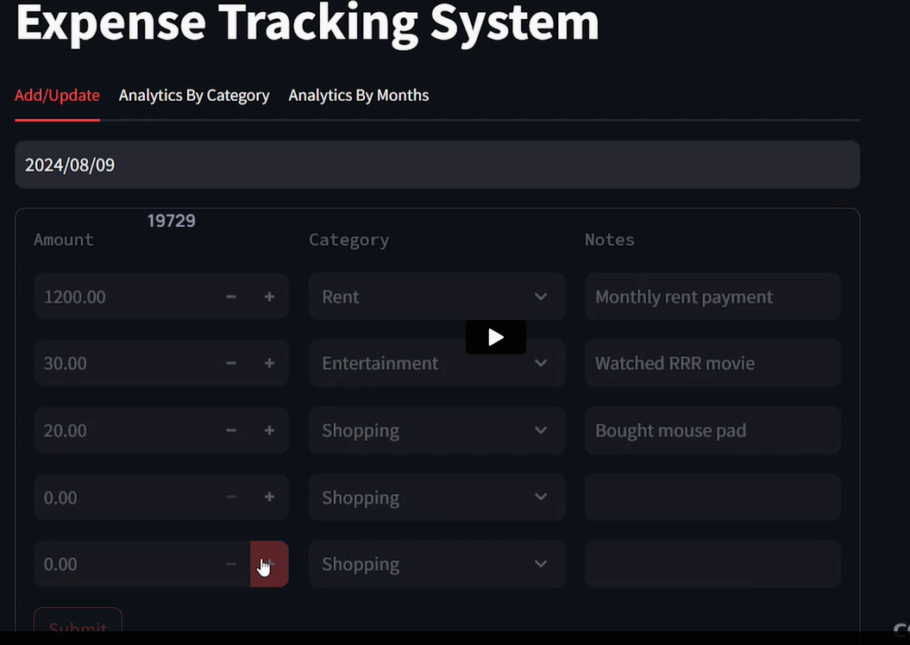

3 tier application

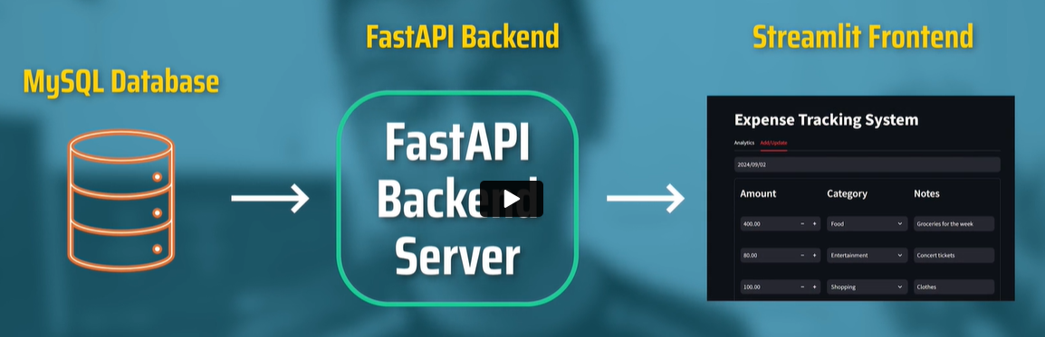

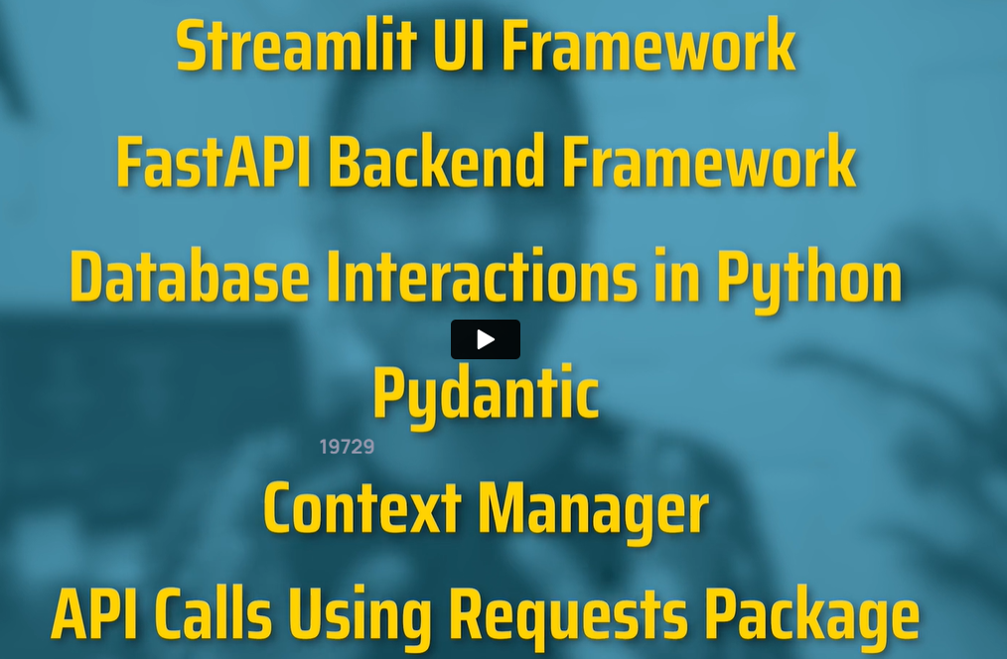

**Python installation:**

Remove older version of Python.

Windows – Add or Remove programs

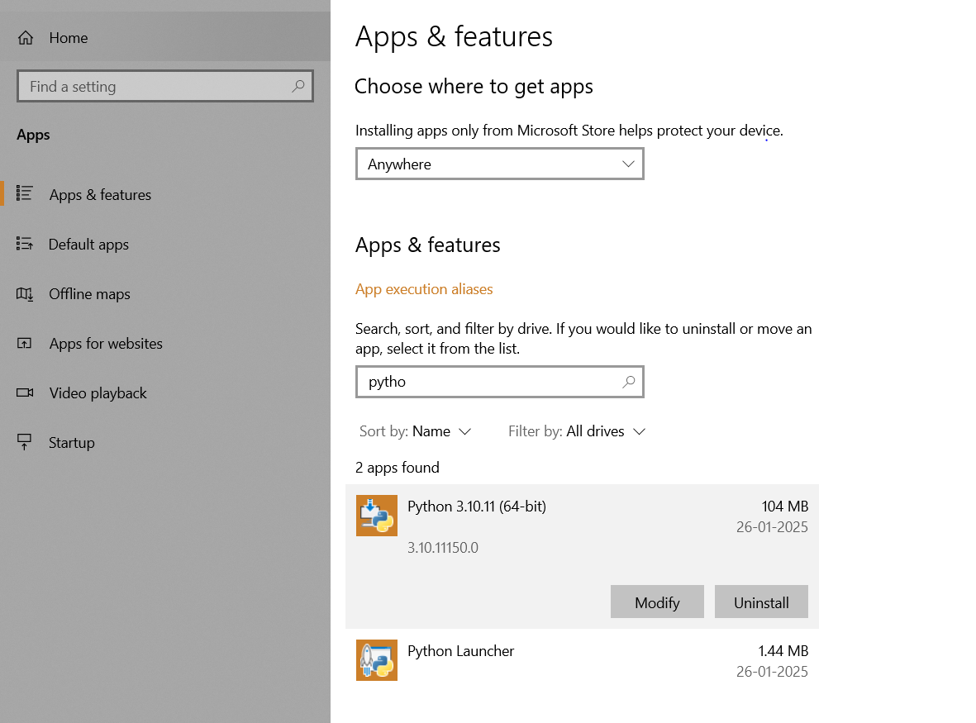

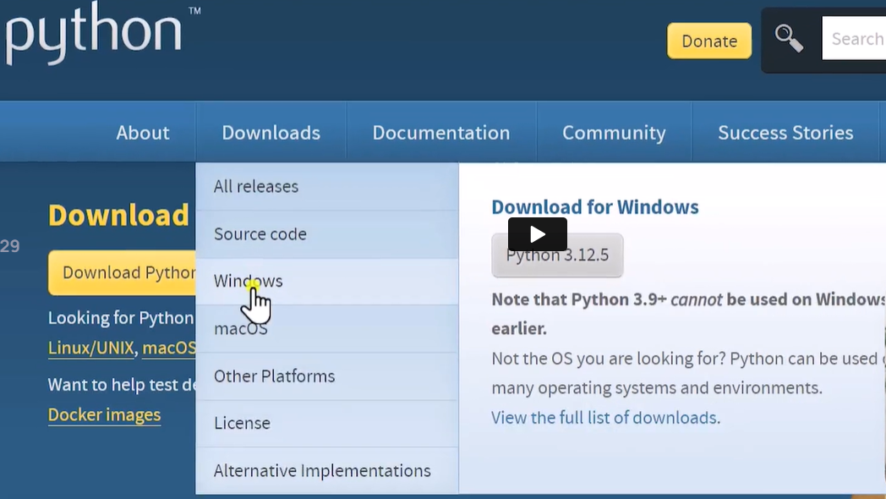

Window – System information – to verify 64 bits

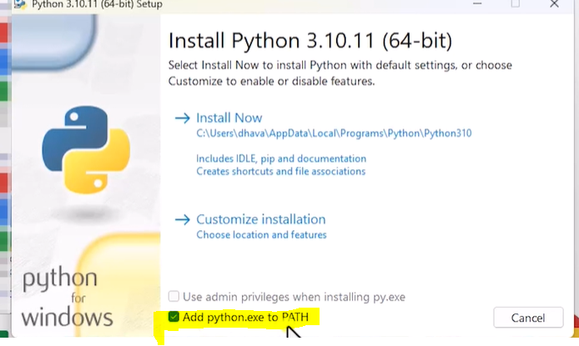

Edit system env variable (after installation of Python)

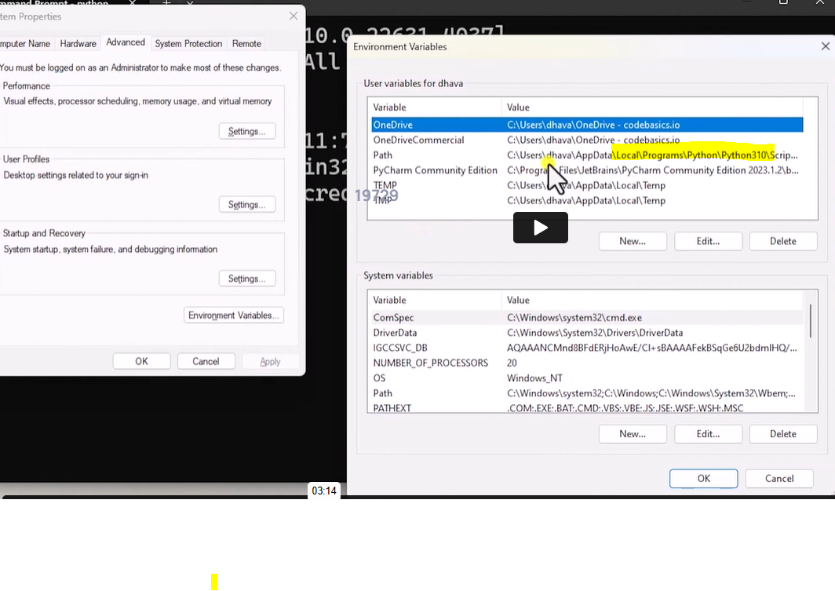

Since env variable has python path, cmd will show the python details

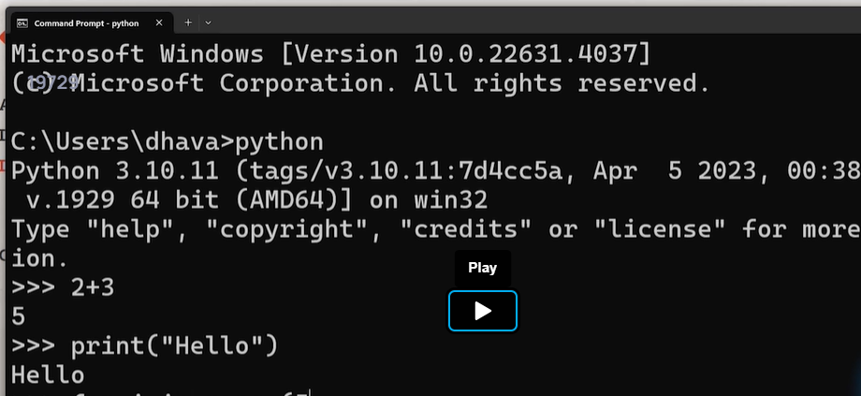

Ctrl Z to exit Python commands

Install Gitbash -this is to run Unix commands in Windows computer

Ls in Gitbash, dir in Cmd

Cd in Gitbash not cd in cmd

Pip is the utility we get with python installation

Jupyter is one of the package in python

Pip install jupyter

Launching Jupyter is two ways

1. Create a code folder in C directory

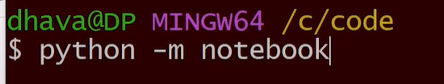

1. Jupyter notebook

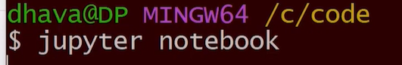

Join discord server (chapter 2)

**Variables**

Data type is not needed to create a variable

Reserved keywords cannot be used as variables

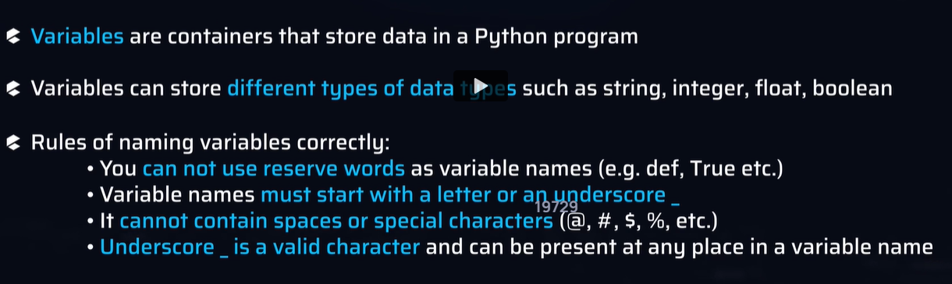

Python official documentation

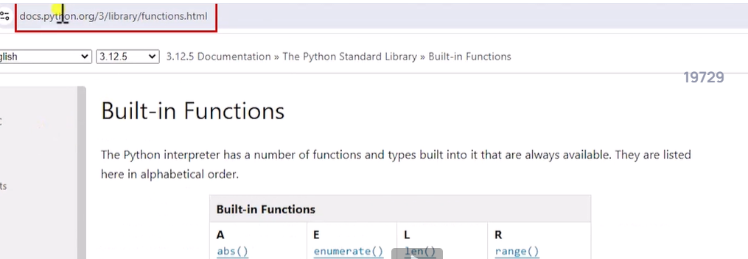

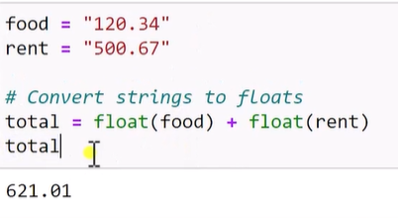

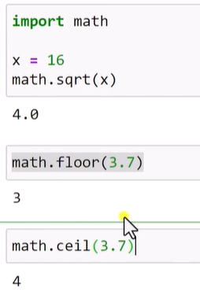

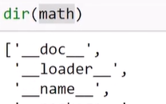

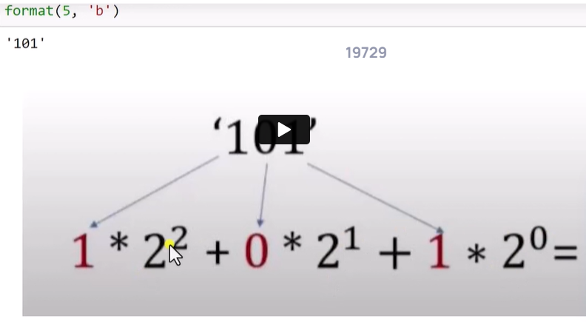

How float is stored in computer

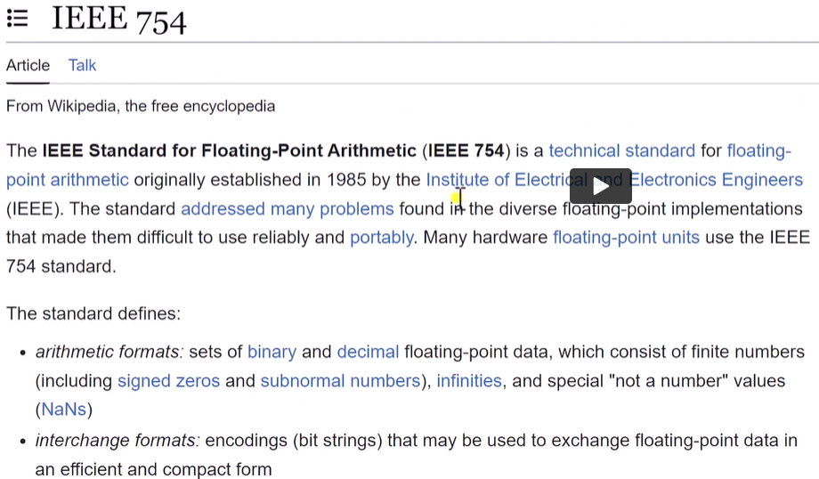

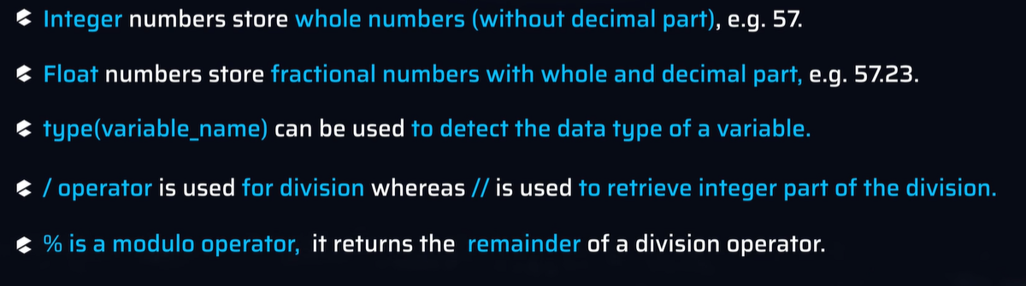

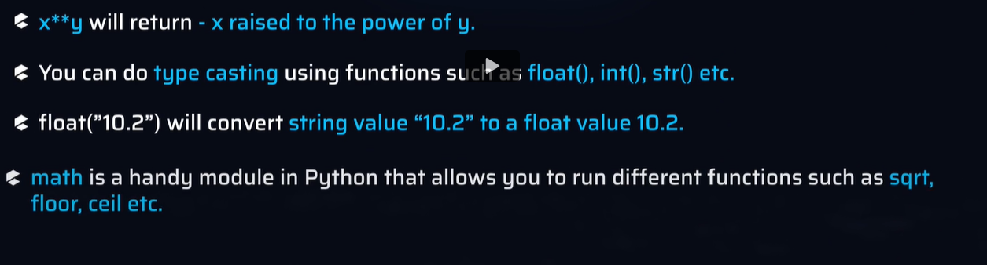

**STRINGS**

Both single and double quotes are allowed

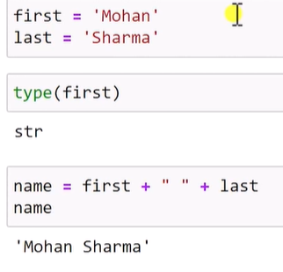

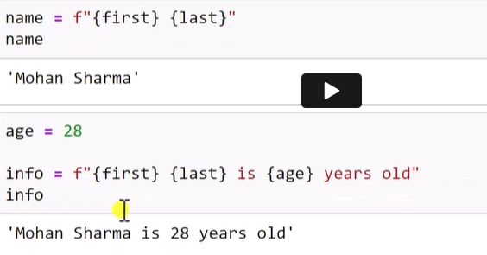

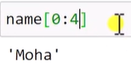

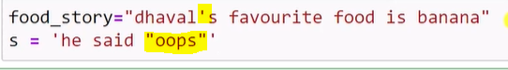

**Print function will remove \n in output**

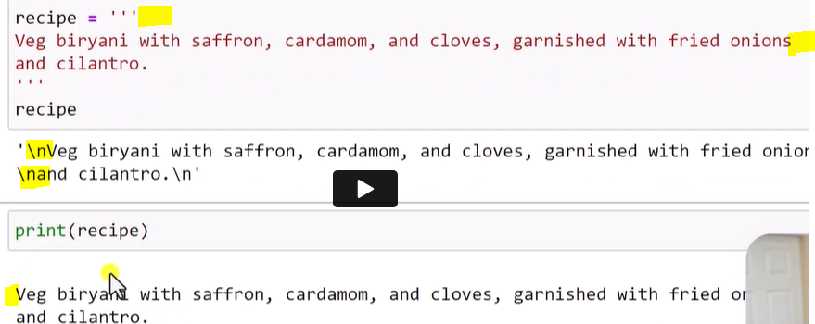

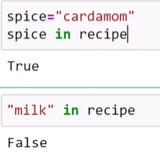

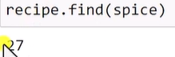

dir(s) - lists all function

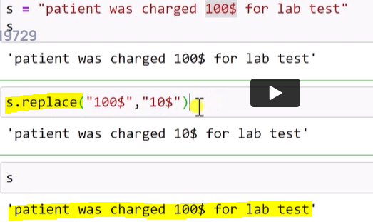

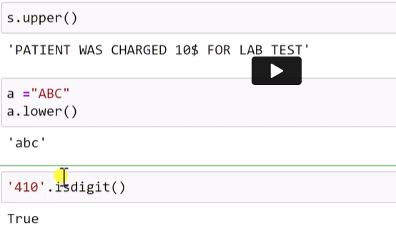

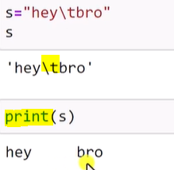

**Split function**

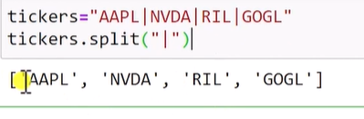

**Strip function**

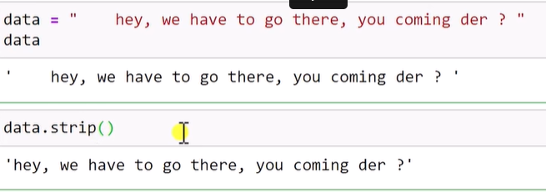

**Detecting file type**

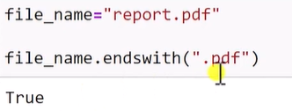

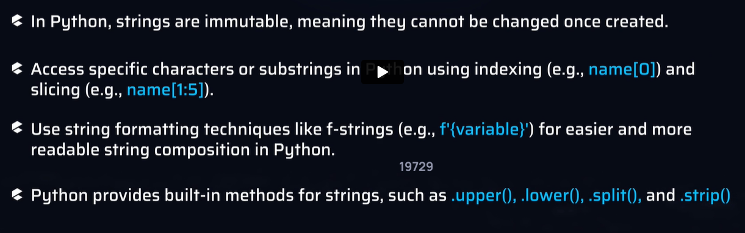

**Lists, If condition and For loop**

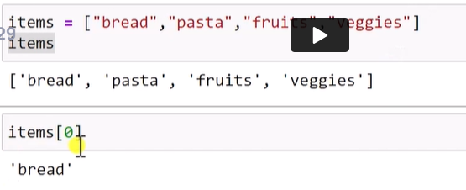

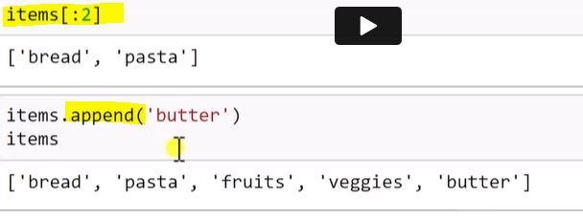

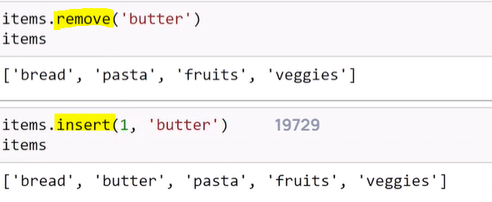

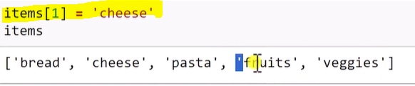

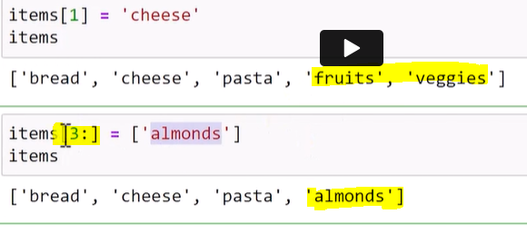

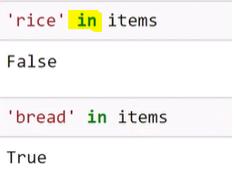

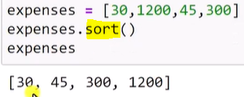

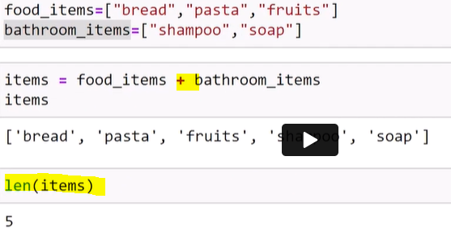

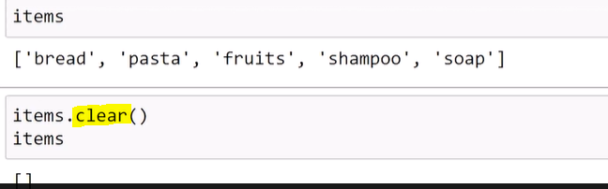

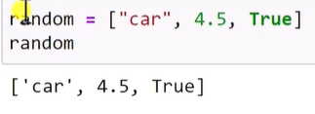

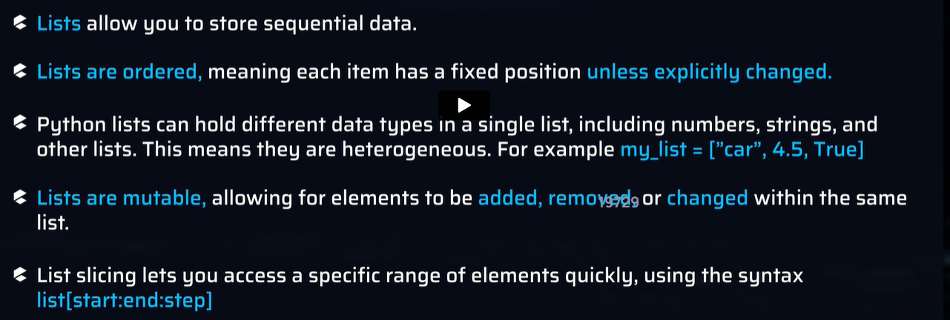

**If condition**

Ternary operator

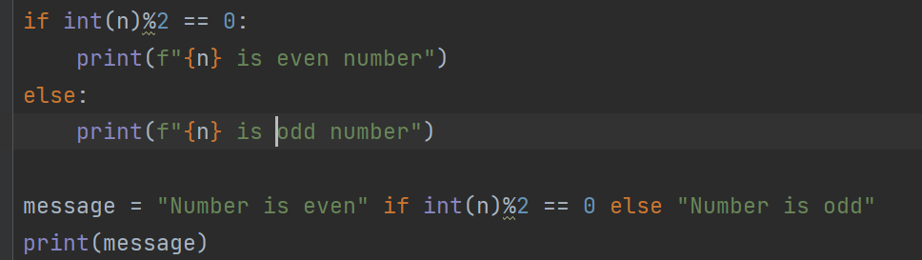

Terminal and console

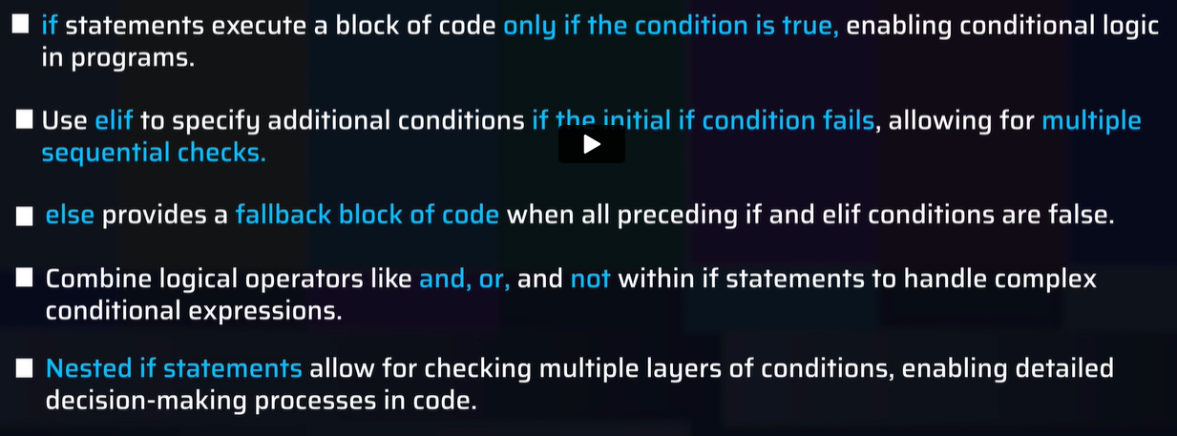

For loop  
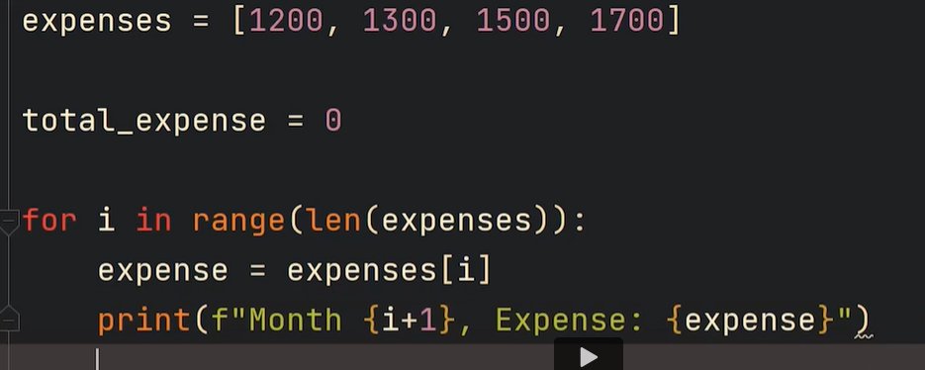

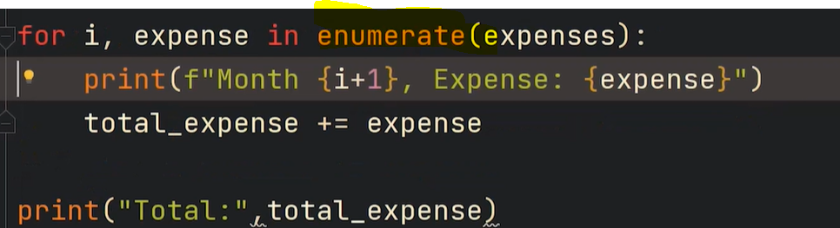

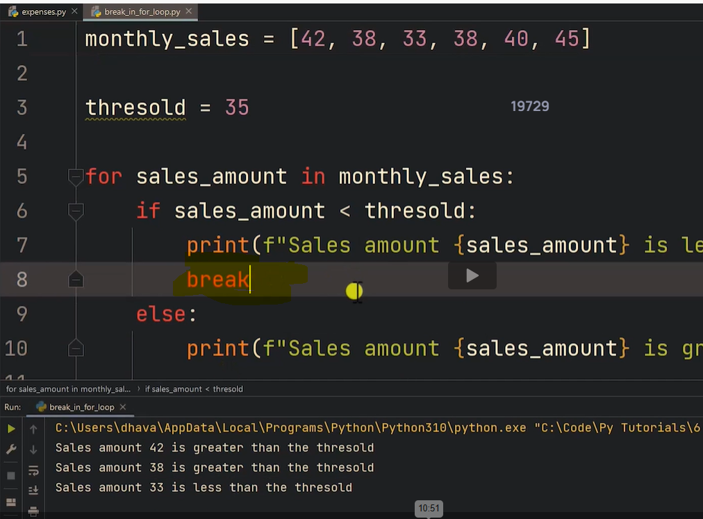

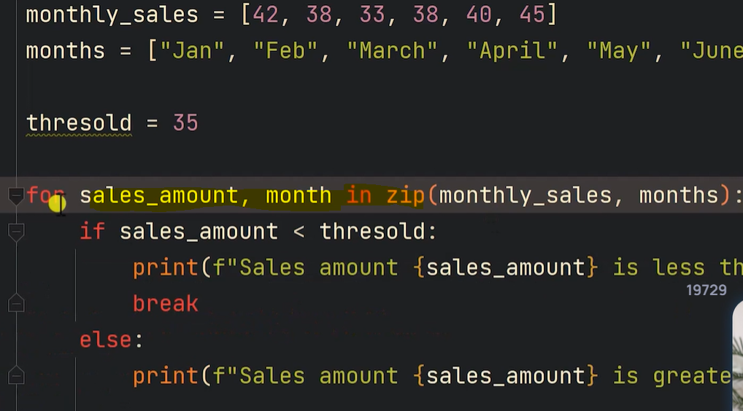

Odd numbers

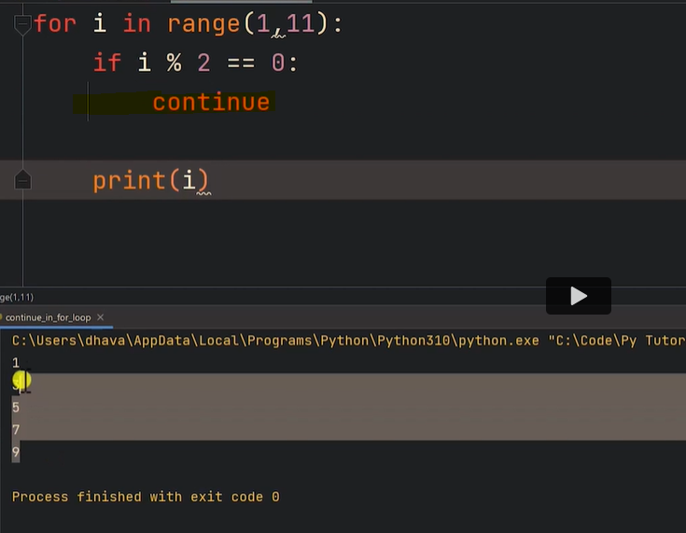

Continue ignores current iteration and proceed with next value of I variable in loop

**Nested For loop**

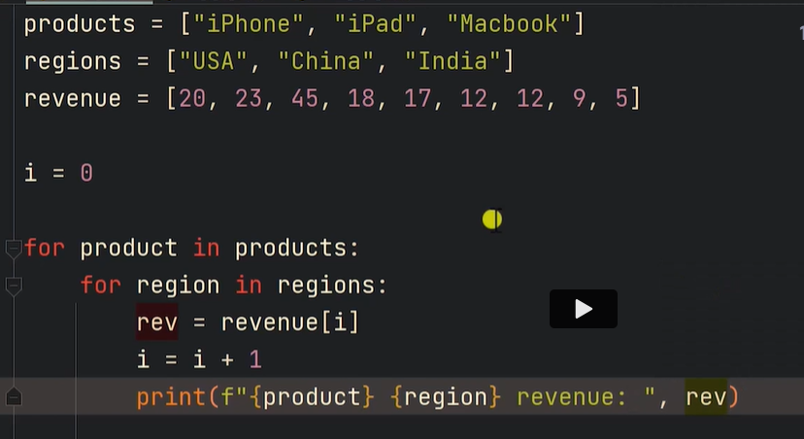

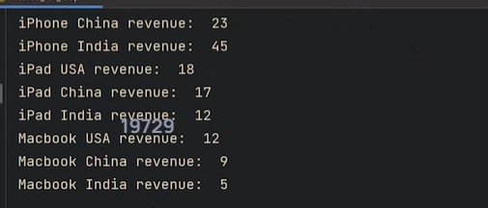

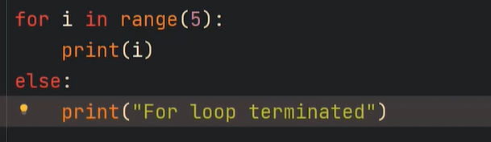

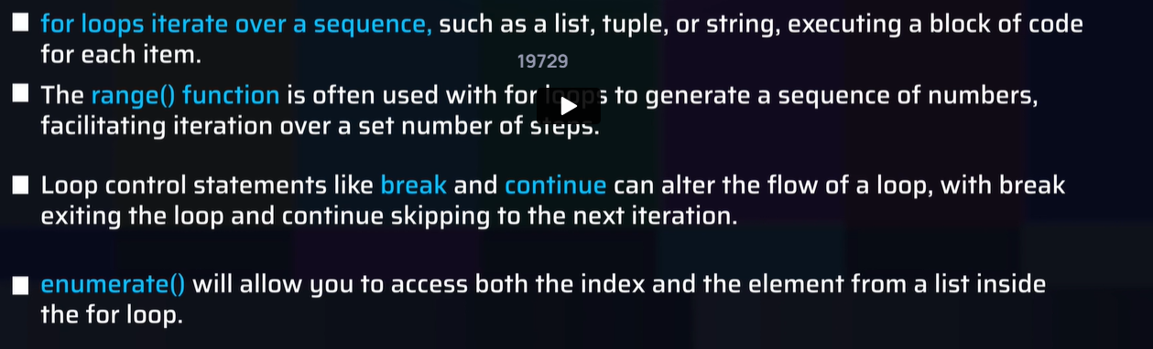

**Function:**

expenses = [1200, 1300, 1500, 1700]  
  
  
def total_calculation(exp_list):  
 *'''* ***:param*** *exp_list: input list containing numbers* ***:return****: total sum of all numbers in the input list  
 '''* total = 0  
 for e in exp_list:  
 total = total+e  
 return total  
  
  
sum = total_calculation(expenses)  
print(sum)  
  
print(help(total_calculation)) - prints the documentation of the function

**Position argument, Keyword arguments, default arguments**

*arg – tuple

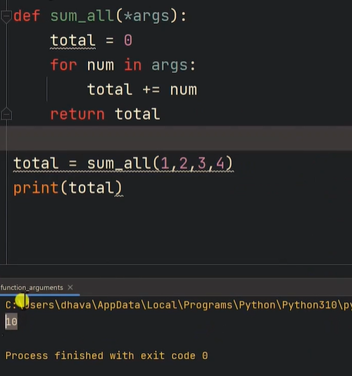

**kwarg – keyword argument

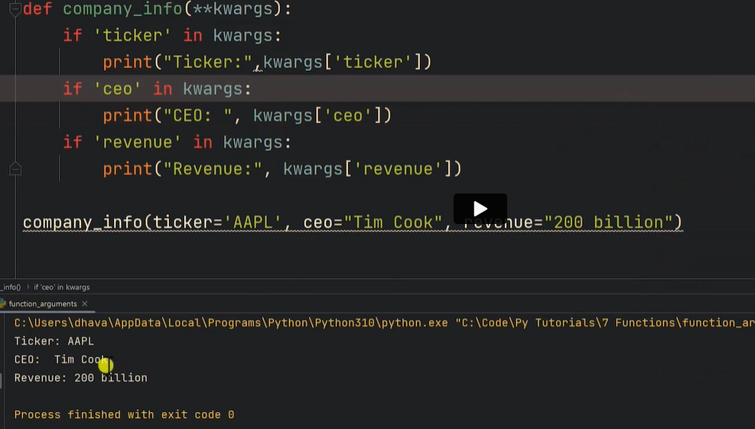

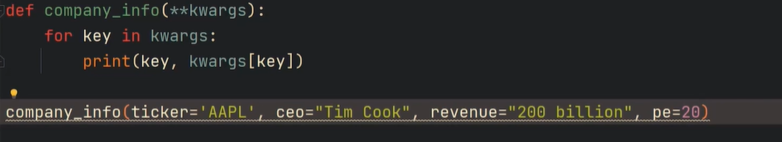

**Lambda function**

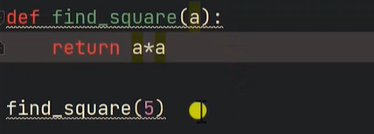

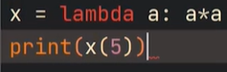

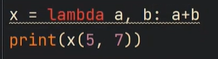

**Buildin functions**

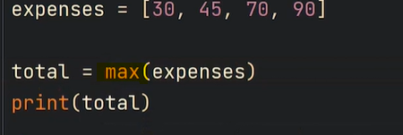

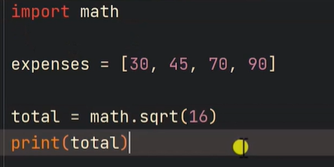

**Pass - used in interfaces. User created functions are called User defined functions**

def func()

Pass

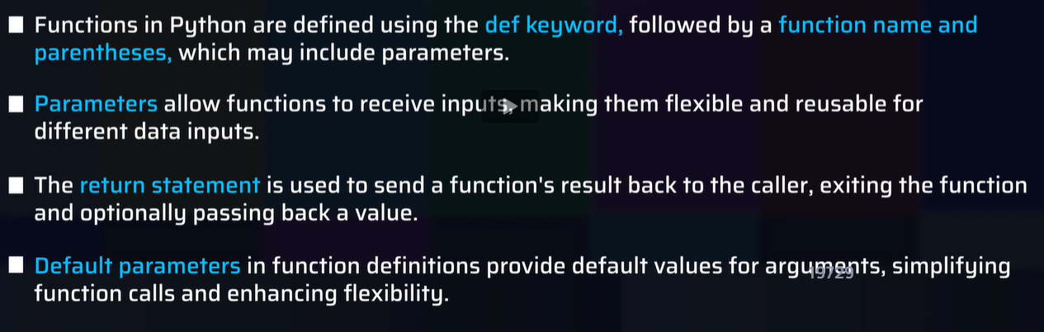

**Dictionaries and Tuples**

Tuple elements cannot be changed, fixed size, cannot append like list, memory optimized

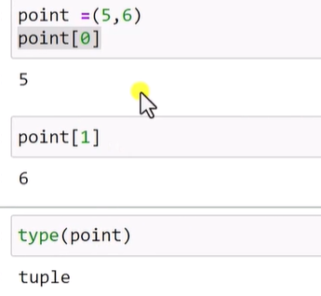

**Return as tuple and unpack it**

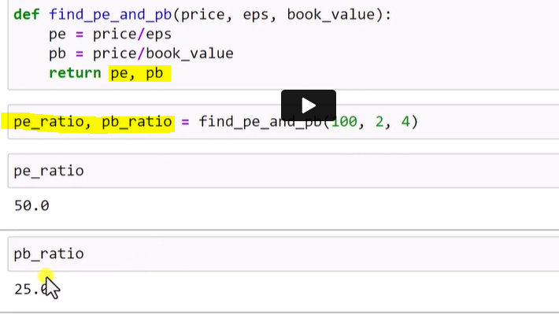

**List of tuples**

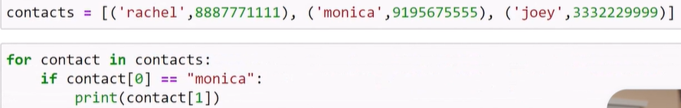

This is Big O – order of n (computational cost)

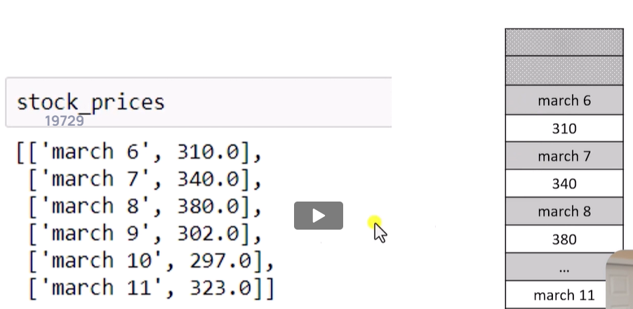

**Hashmap to be used for memory efficient program. Hashmap is implemented in python as Dictionary**

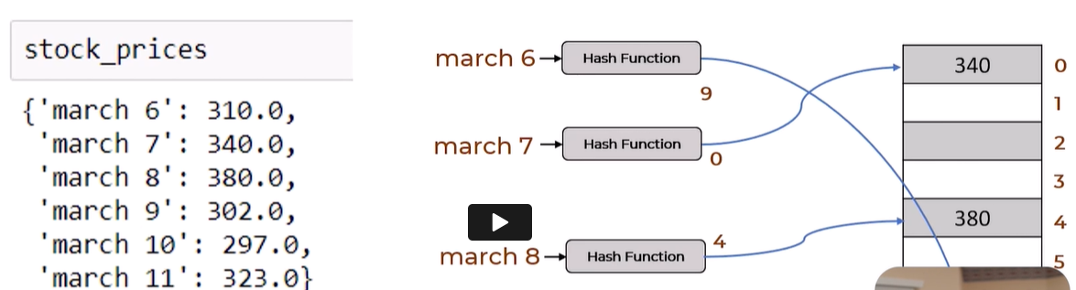

Finding a value in dictionary is constant (means hash time)

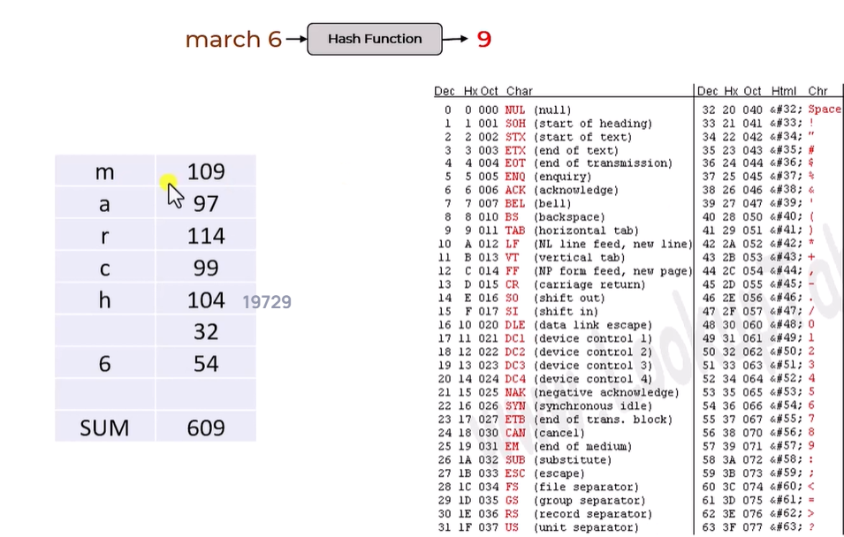

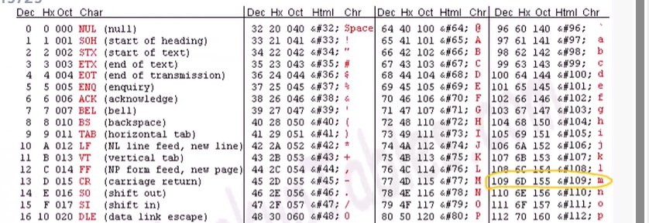

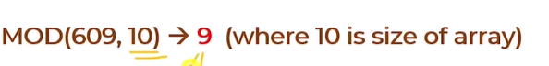

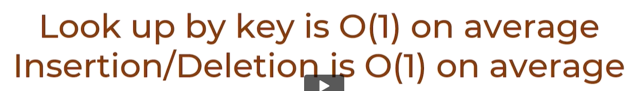

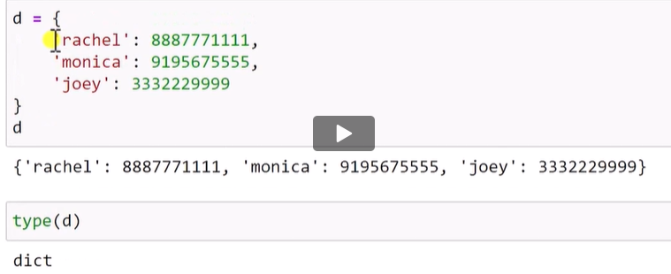

Keys can be numbers as well

**Get function return none if no match**

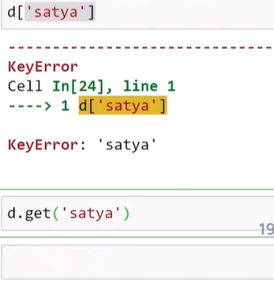

**Adding an item**

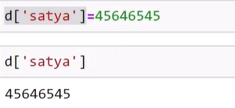

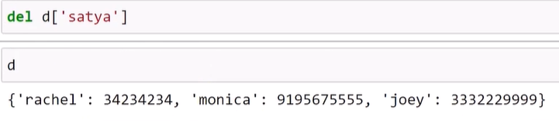

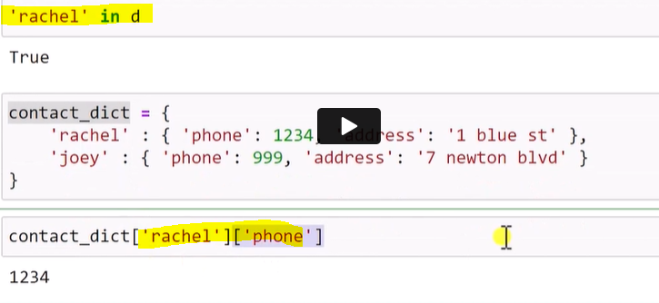

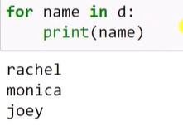

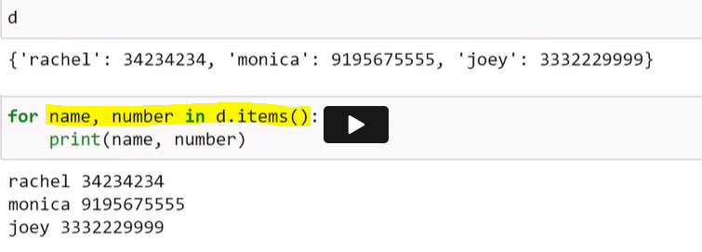

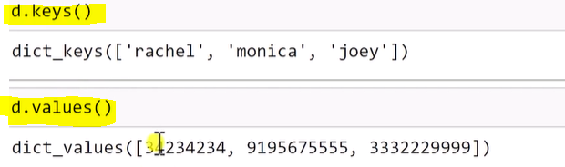

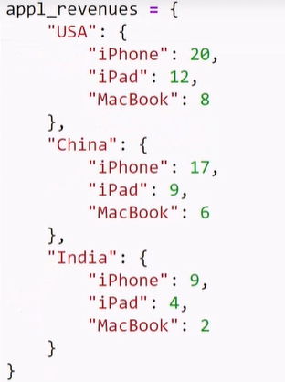

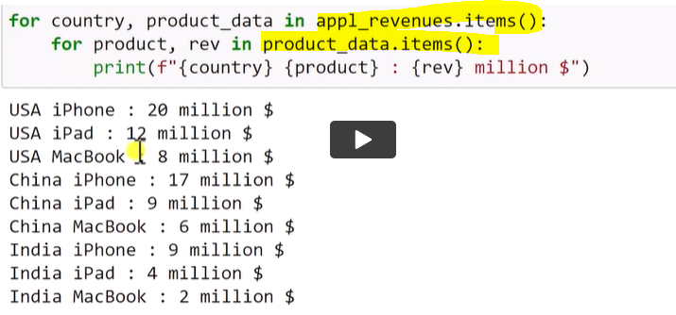

**Different APIs**

Dir(d)

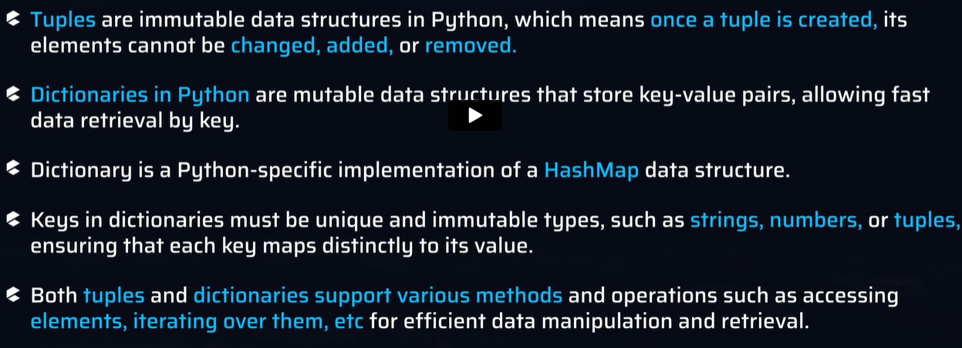

**Modules**

**In build modules come with python installation**

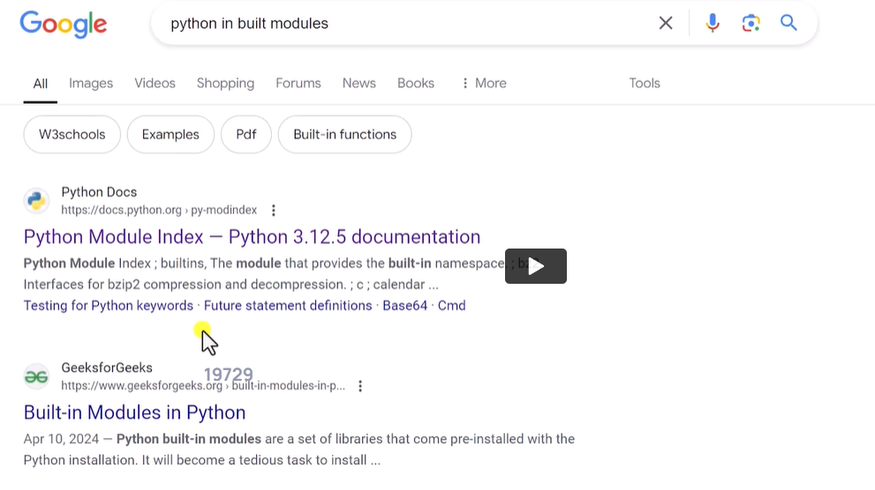

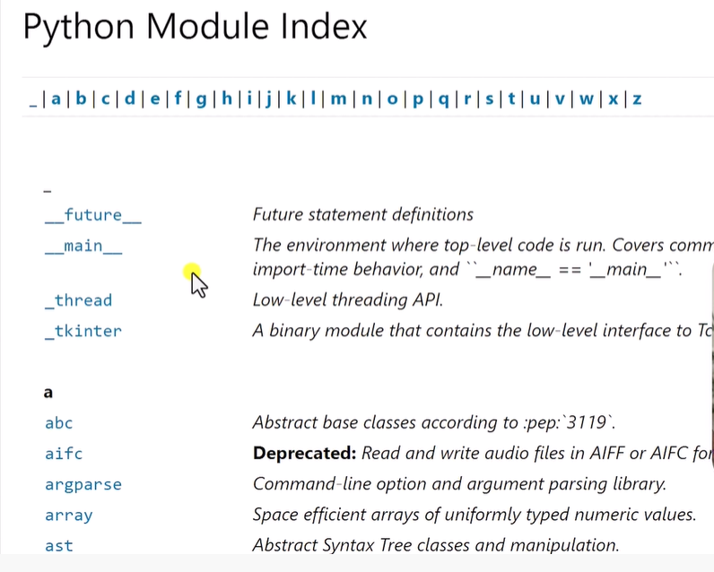

dir(math) – list all the function available in math module(module like file, function – function inside files), package like folder

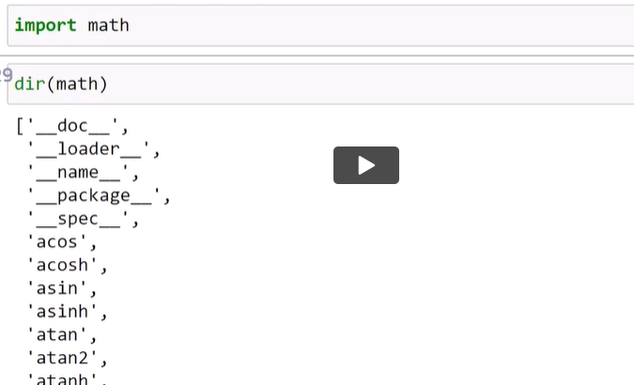

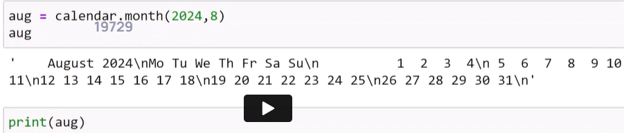

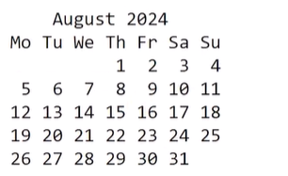

External modules – need to install separately if needed

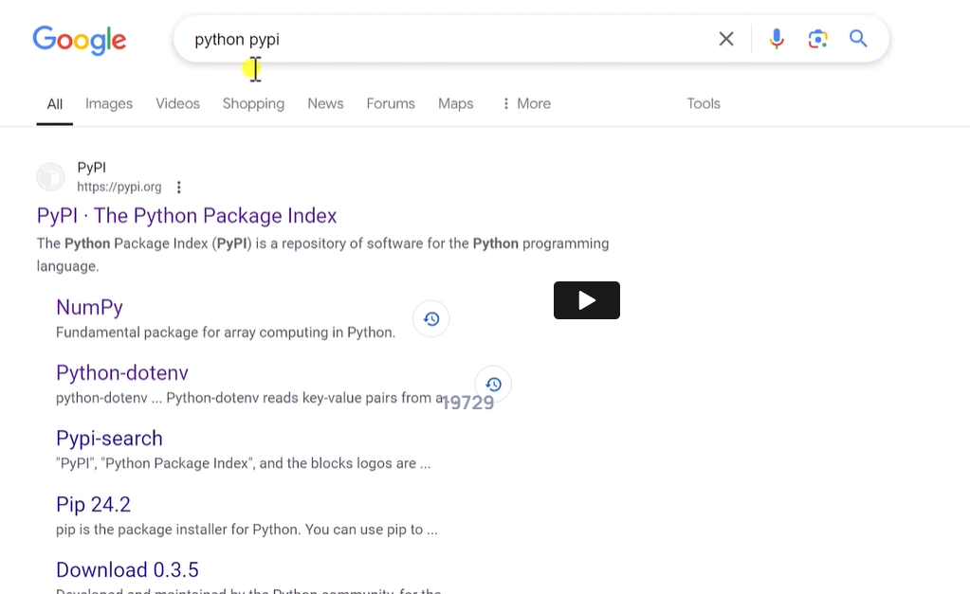

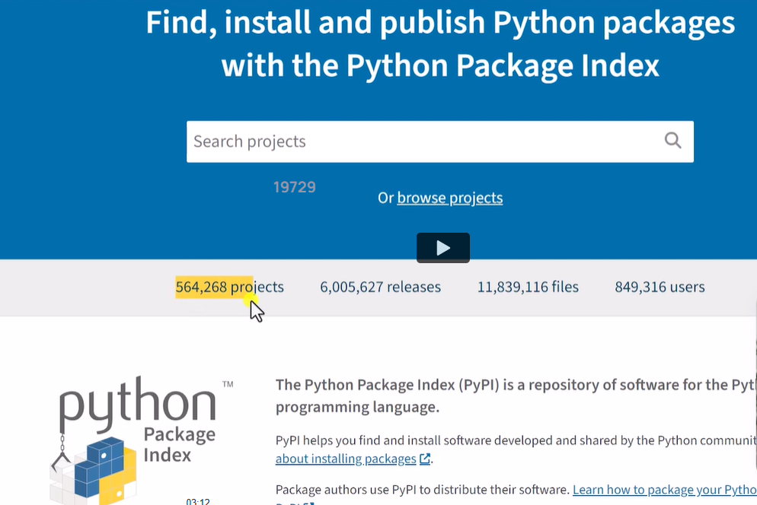

Numpy, pandas and scikit-learn (used in ML)

To check version of a module

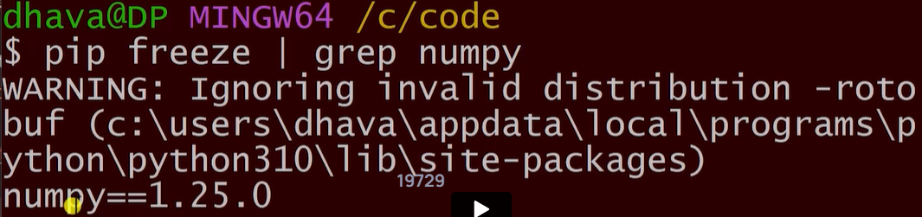

**User defined functions**

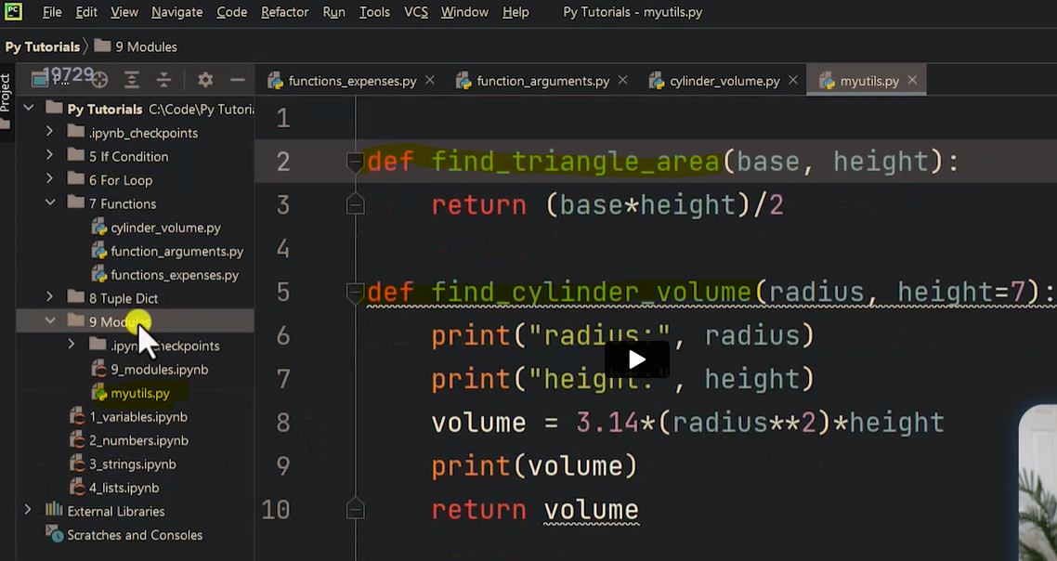

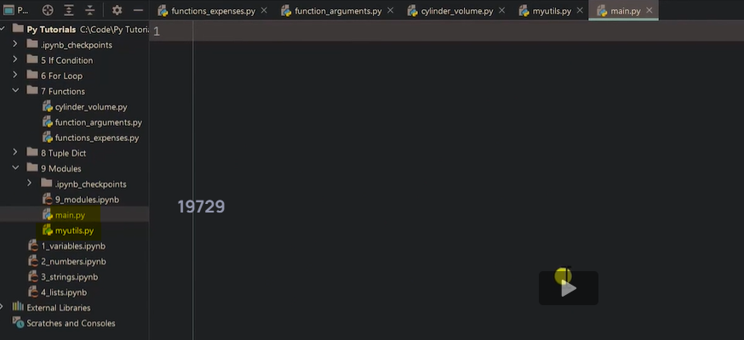

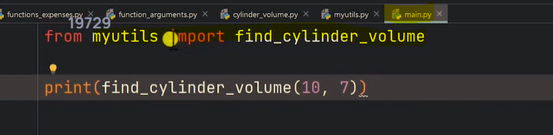

Import module aloine

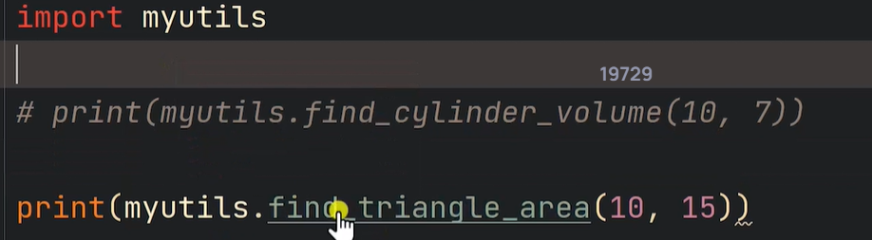

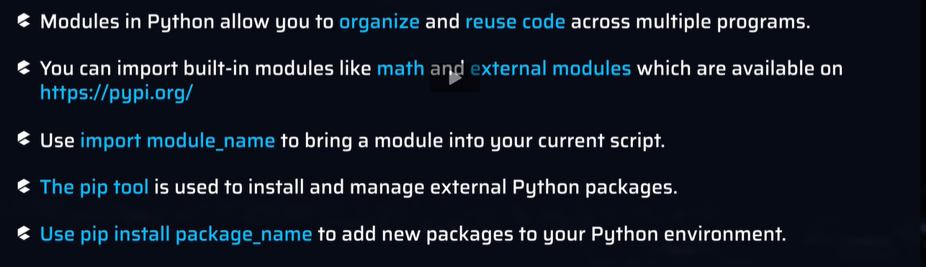

**Files:**

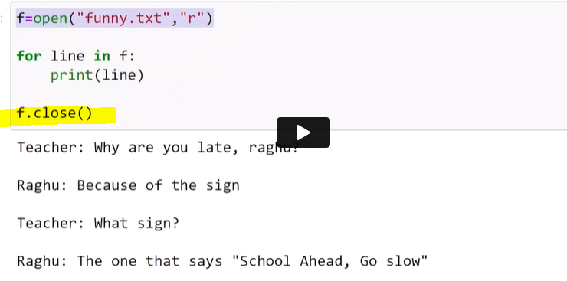

**f.close() – deallocate the resoures**

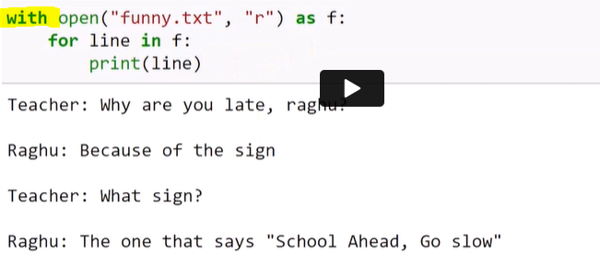

Each lines in file stored as element of a list

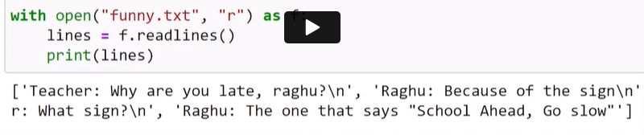

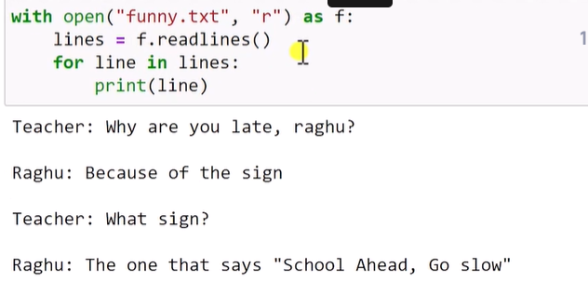

**Create a new file and writes the content**

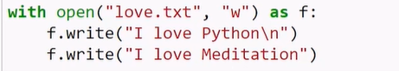

**Append a file**

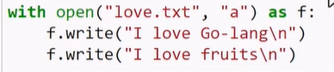

**Write lines in single command**

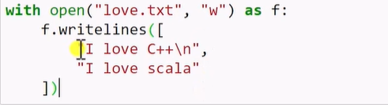

**Files**

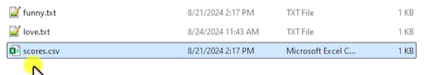

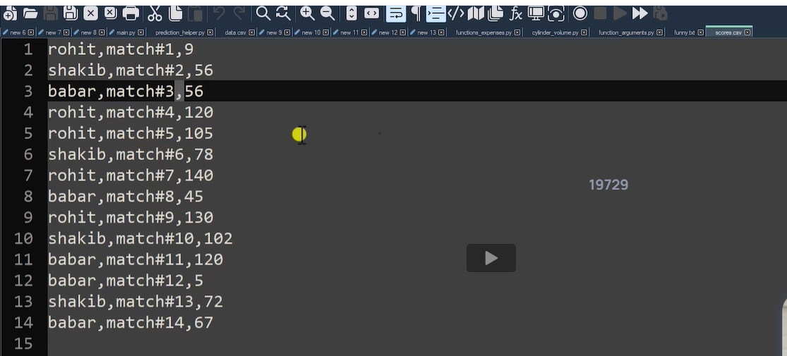

Use \\ in case of windows

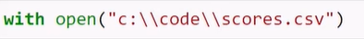

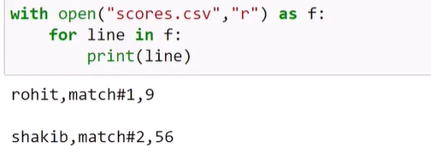

**Creating dictionaries from file.csv**

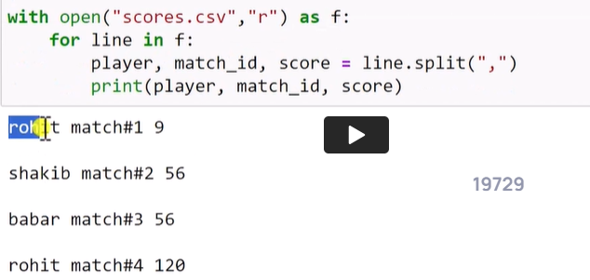

‘-‘ = Ignore the value

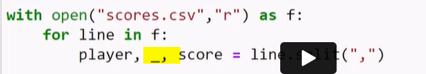

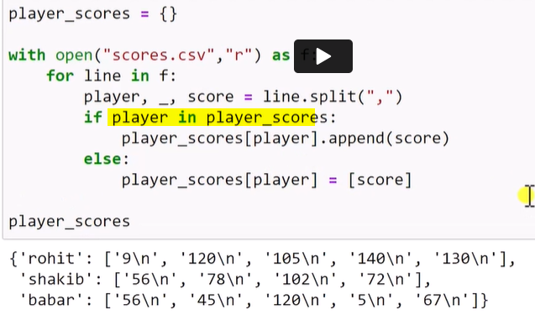

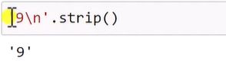

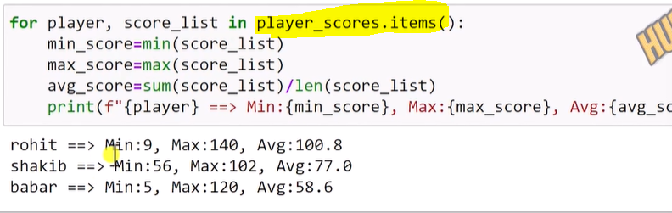

Remove a file

